Dongfeng 5 square refueling truck
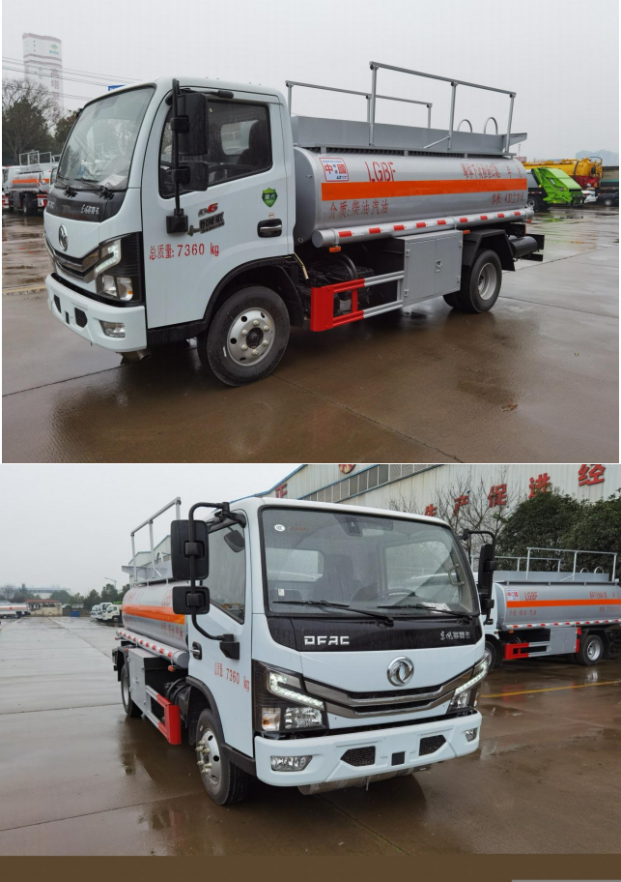

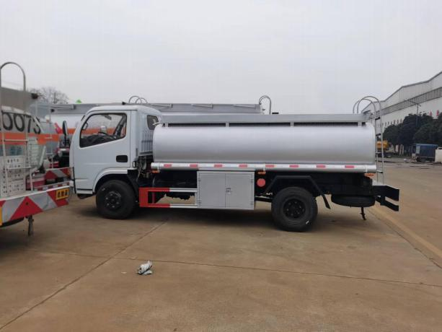

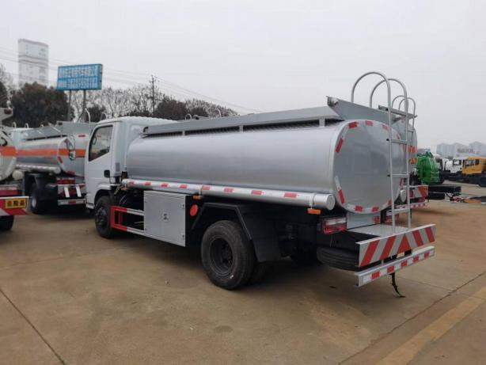

[Vehicle technical parameters]
product name | refuelling truck | product model
Total mass (Kg) | 7360 | Tank volume (m 3) | 4.31
Rated load mass (Kg) | 3410 | Overall dimensions (mm) | 5995×2000×2500
Reconditioning mass (Kg) | 3820 | Box dimensions (mm) | × ×
Rated passenger capacity (person) |  | Total mass (Kg)
Number of passengers (cab (person) | 2 | Maximum load mass of the saddle (Kg)
Approach angle / departure angle to (°) | 27.7/15 | Front suspension / rear suspension (mm) | 1055/1632
axle weight (Kg) | 2640/4720 | Max. vehicle speed (Km / h) | 80
remarks | Optional front cover, front bumper, front combination lamp, rearview mirror. Select the left and right fuel tank position, select the guardrail style. Can effective volume 4.31 cubic meters, dangerous goods transport vehicle type is FL type, item number: 3, tank size (long shaft short shaft) (mm): 1, the tanker in the front of the tank: 4000 (including tanker warehouse 900) 17501150.2, tanker on the side of the frame side: 400016001000,39001500900. Choose 3308mm wheelbase. Side and rear protection is welded connected with Q 235 material, Size of the rear protective section (mm): 50100, Back Protection height (mm): 430.ABS model / manufacturer: ABS model: ABS / ASR-24V-4S / 4M, Manufacturer: Xiangyang Dongfeng Longcheng Machinery Co., Ltd., Tanker device model and manufacturer: BL 1111Z / Zhuhai Beilin Refueling Equipment Co., LTD., Zhongshan Branch, HS 1812B, HS 2812B / Token Hengshan Technology (Guangzhou) Co., Ltd., SKES-1112 / Henghe Jiahua Technology Co., Ltd. (Shanghai Bora Machinery Co., Ltd.), SK 20QF-111A, SK 20QF-222A / Zhengzhou Sanjin Petroleum Equipment Manufacturing Co., Ltd., CS 20D 1110F / Sinstar Technology Ltd, JSK-70B 1121CZ, JSK-70B 1121C, JSK 45B 1121C / Beijing (Beijing) Petrochemical Equipment Co., Ltd., XTST 121BF 1 / Xingtai Zhengruntong Technology Development Co., Ltd., ZH 3111 / Foshan Zhongze Electromechanical Technology Co., Ltd. BJJ-20-AH 2 Anhui Ling Metrology Manufacturing Co., Ltd. Install the travel recorder with satellite positioning function, and the exhaust pipe is in front. Install front disc brake and speed limit device, speed limit of 80km / h, only chassis radial tires. The vehicle steering wheel has been equipped with the chassis tire burst emergency protection device.
[Chassis technical parameters]
Chassis model | EQ 1075SJ 3CDFWXP | Chassis name | truck chassis
brand name | Dongfeng brand | manufacturing enterprise | Dongfeng Motor Co., Ltd
number of axles | 2 | Number of tires | 6
Wheelbase (mm) | 2700,2950,3308
tyre size | .007R 16,7.00R 16LT 14PR
Number of steel plate spring sheets |  | Front wheel pitch (mm) | 1525,1519
Fuel types | Diesel, gasoline | Rear wheel pitch (mm) | 1498,1516,1586,1670
Emission compliance standards | GB 3847-2005, GB 17691-2018 countries
engine type | Engine manufacturer | displacement (ml) | power (Kw)
CY 4BK 461 | Dongfeng Chaoyang Chachai Power Co., LTD | 3707

Chassis configuration: using the original Dongfeng stock dangerous goods special chassis, the new Dongfeng Dorica D6S single row cab, China sanchaochai 82 horsepower diesel engine, Jiangkai 5 gear, front bridge 2 tons rear bridge 4 tons, 700 wire tire, dynamic turn air brake. Electric doors and Windows, central control lock, broken air brake, ABS, exhaust pipe front.
Upper configuration: tank announcement 4.31 square meters (actual volume of 5m³), transportation medium: diesel oil, kerosene, gasoline.Tank thickness is greater than or equal to 4.2mm, European full set (a European tank, a submarine valve, a steam recovery, a overflow rod, a electrostatic socket, an outlet), with large flow tanker and 15 meters automatic back oil coil, with folding guardrail, two tank as long oil pipe, two fire extinguishers, a fire cap. Other standard equipment, paint: silver ash, paste reflective strip, reflective belt, safety notice.

Quote of Cheng Li Special purpose Automobile Co., Ltd

product name | configure | Quantity (vehicle) | Unit price (ten thousand yuan) | Freight (ten thousand) | Total (ten thousand)
Five square refueling trucks | See details
Note: 1. Deposit of 30% for the production car
2. Pay the full payment before leaving the factory
3. Delivery within 15 working days after signing the contract
4. The above quotation includes tax and freight

yours sincerely!
Cheng Li Special purpose Vehicle Co., Ltd

